Question for AI Model

1. Compare Lender Risk Fee between Pepper and Resimac

Resimac is

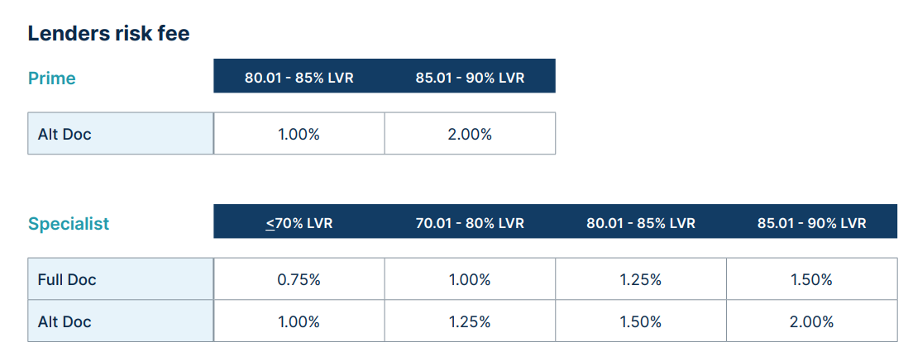

Pepper is on page

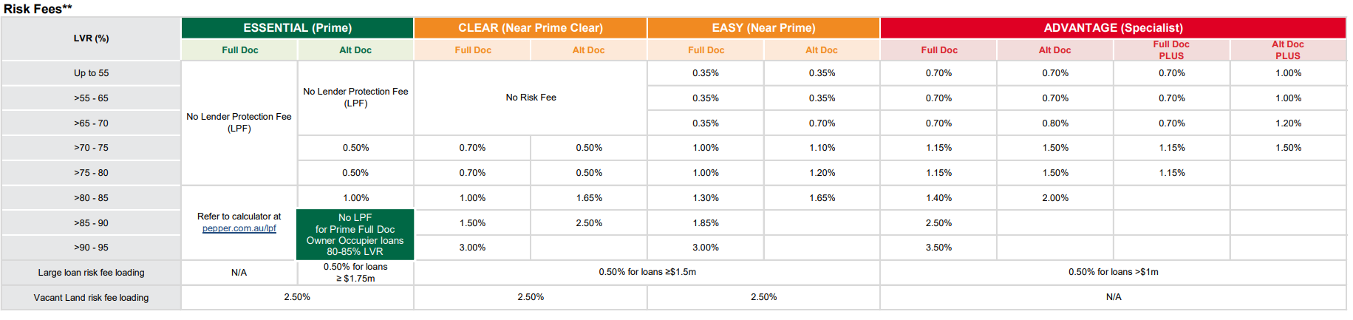

Q,2 Compare product types of Pepper vs Resimac

Pepper is

Resimac is

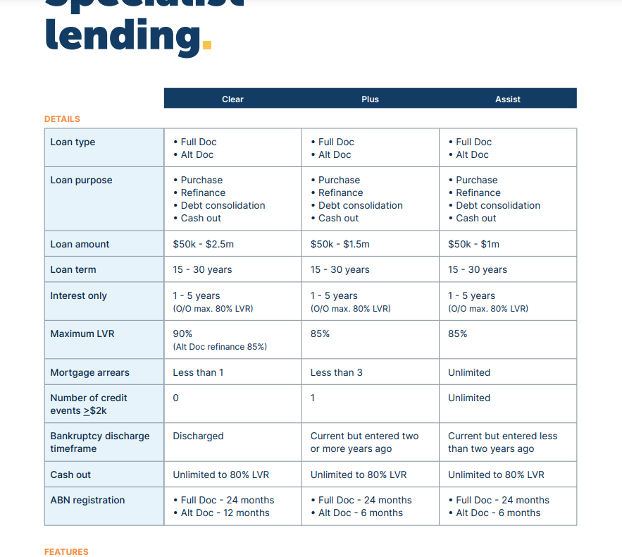

Q.3 Serviceability Comparison between Pepper and Resimac

Resimac

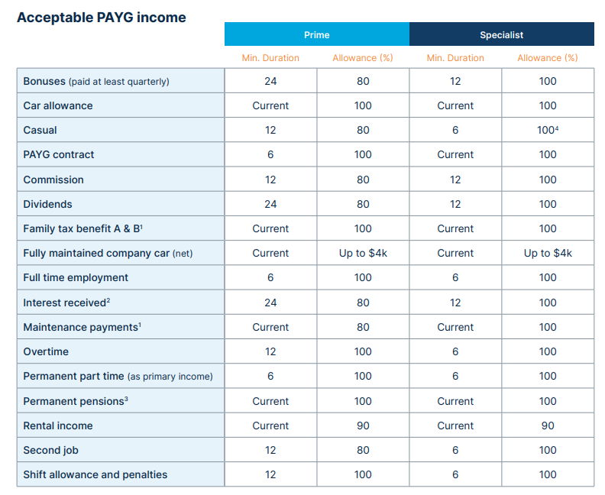

Pepper

